**Setting a DGT 2010 to the new Birmingham League Incremental Time Limit**

This document will outline how to set the clocks from scratch.

Switching the Clock On (and Off)

To switch the clock on, turn the clock upside-down and look at its base.

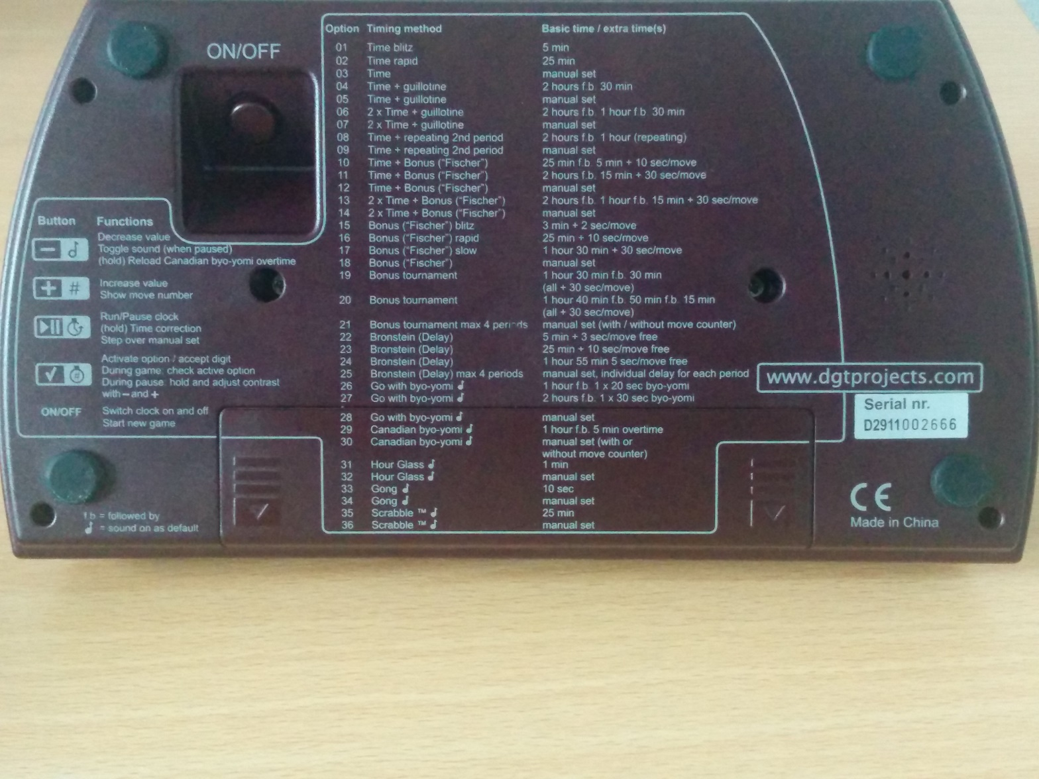

To switch the clock on, you need to press the ON/OFF button.

While we’re looking at the bottom of the clock, it is worth familiarising yourself with the various options available. Mode 5 is ideal for 30/75 + G/15. Mode 7 is ideal for 30/75 + 24/60 + G/15. Mode 21 is designed as a “catch all” mode to enable the user to set anything at all. The Birmingham League’s time limit for increments – 30/70 + G/10 + 10’ – is something that needs to be set in mode 21.

Setting the Clock to Mode 21

Having switched the clock on, you will now see this screen.

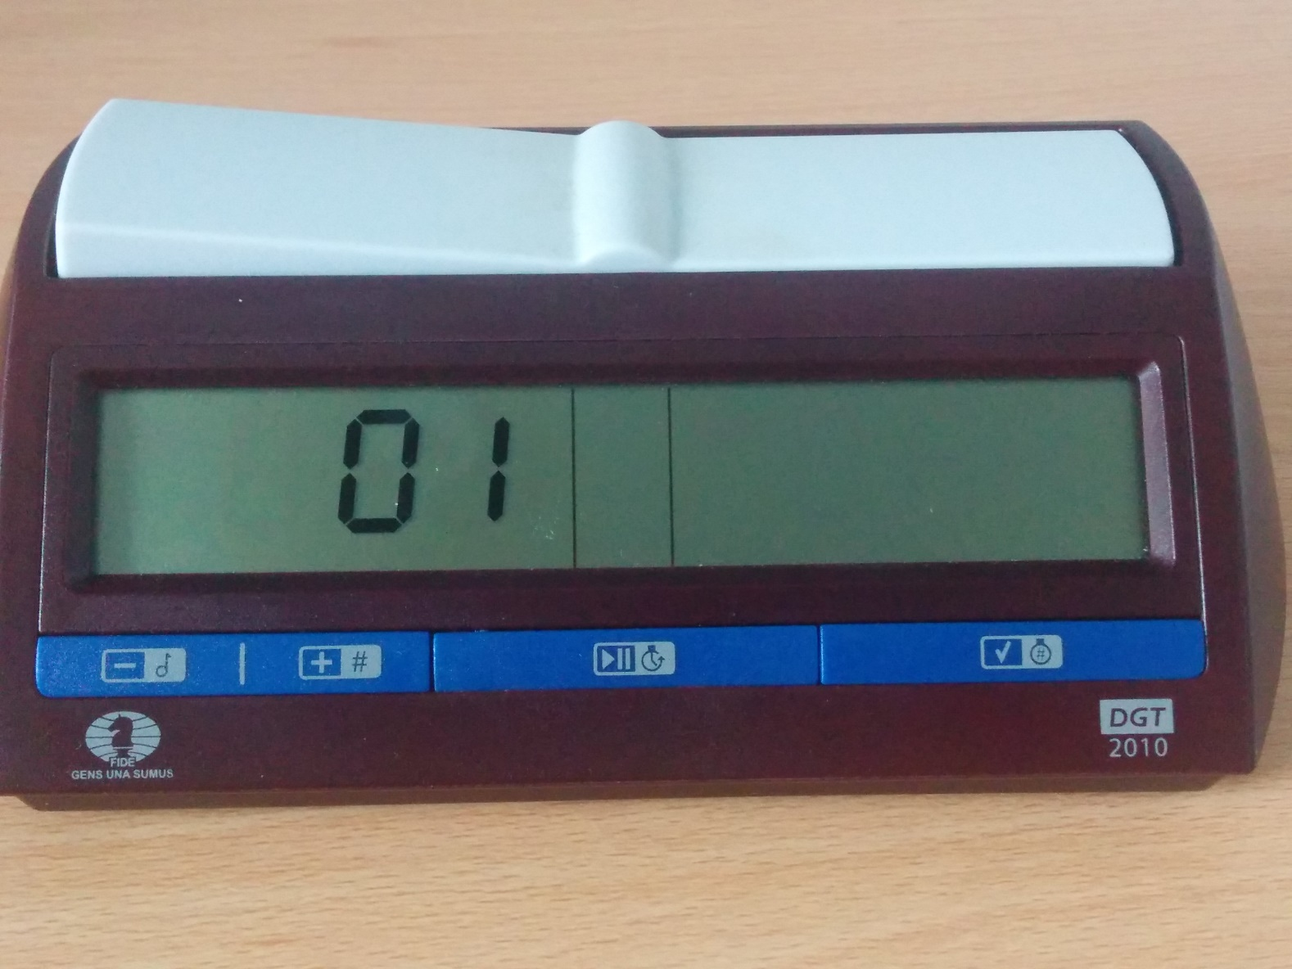

The second digit will be flashing on and off, to indicate that it needs to be set. Clearly, it is hard to capture this in a photograph!

This display of “01” is the mode. This needs to be adjusted to 21. To do this, you can either:

1. Press and hold the - button, on the left of the blue bar across the front. This will cycle through all of the modes going backwards from 01 to 36, 35 and so on, and you let go when you reach 21.
2. Press and hold the + button, which is next to the – button. This will cycle through all of the modes going forwards from 01 and you let go when you reach 21.

It is not necessary in either option to hold the button down – alternatively, you can press the button once to cycle through individual modes, but you will have to press the button more often. Both options are available to you!

When you have finished, the clock should look like this:

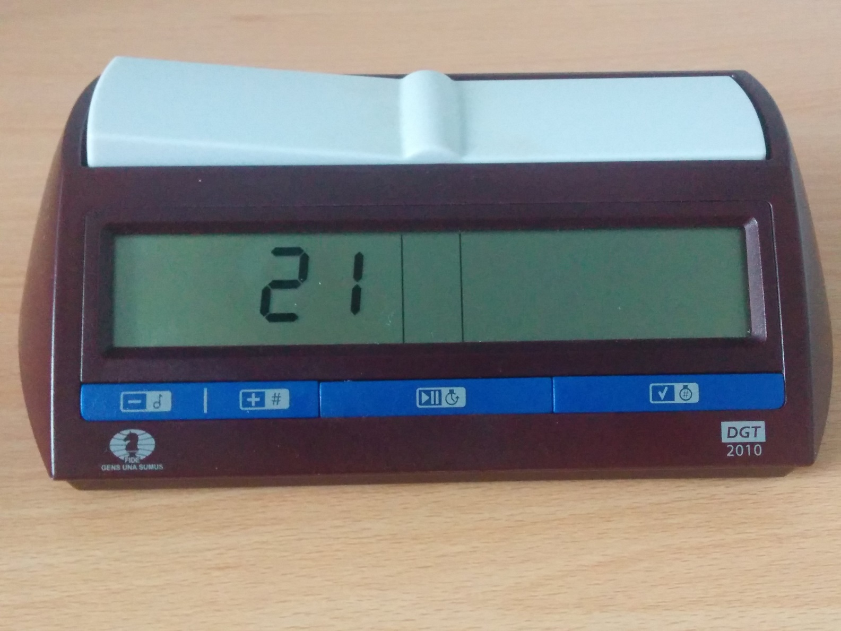

At this point, press the √ button on the right-hand side of the blue bar. This will select mode 21, and you will see this.

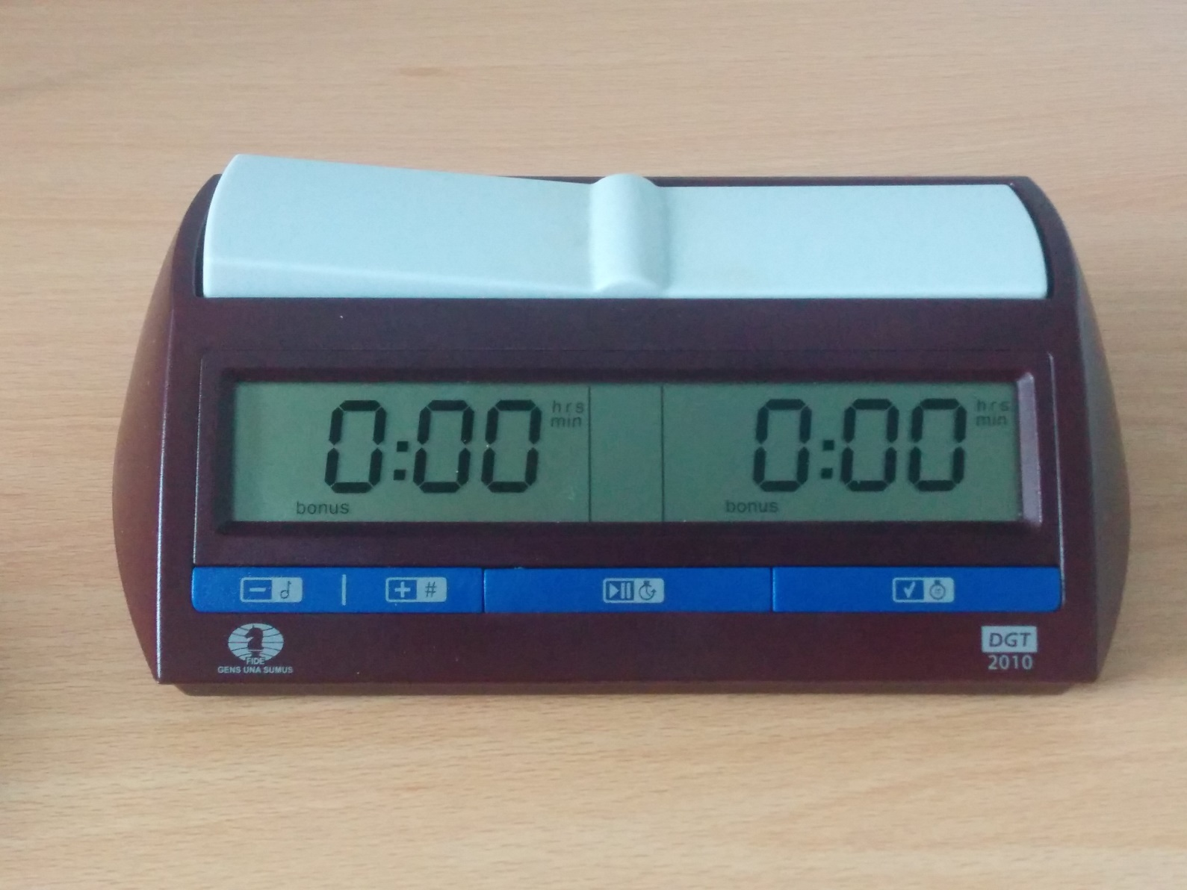

The left-most 0 will be flashing. At this point, it is time to actually set the time on the clocks.

Setting the Time on the Clocks

Having selected mode 21, now we will adjust the time. The basic principles of adjusting the time is easy – there are three buttons you need to use:

1. The – button, which will reduce the flashing digit by 1
2. The + button, which will increase the flashing digit by 1
3. The √ button, which will fix the flashing digit, and allow the next digit to the right to be edited. If you make a mistake, it may be quickest to re-set the clock from the beginning!

Both clocks are showing time in the h:mm format; the seconds will be set later on. With 70 minutes in the first time period, we need to set these clocks to 1:10.

From the photo above, if you press the + button, and then √ you will set the first digit to a 1.

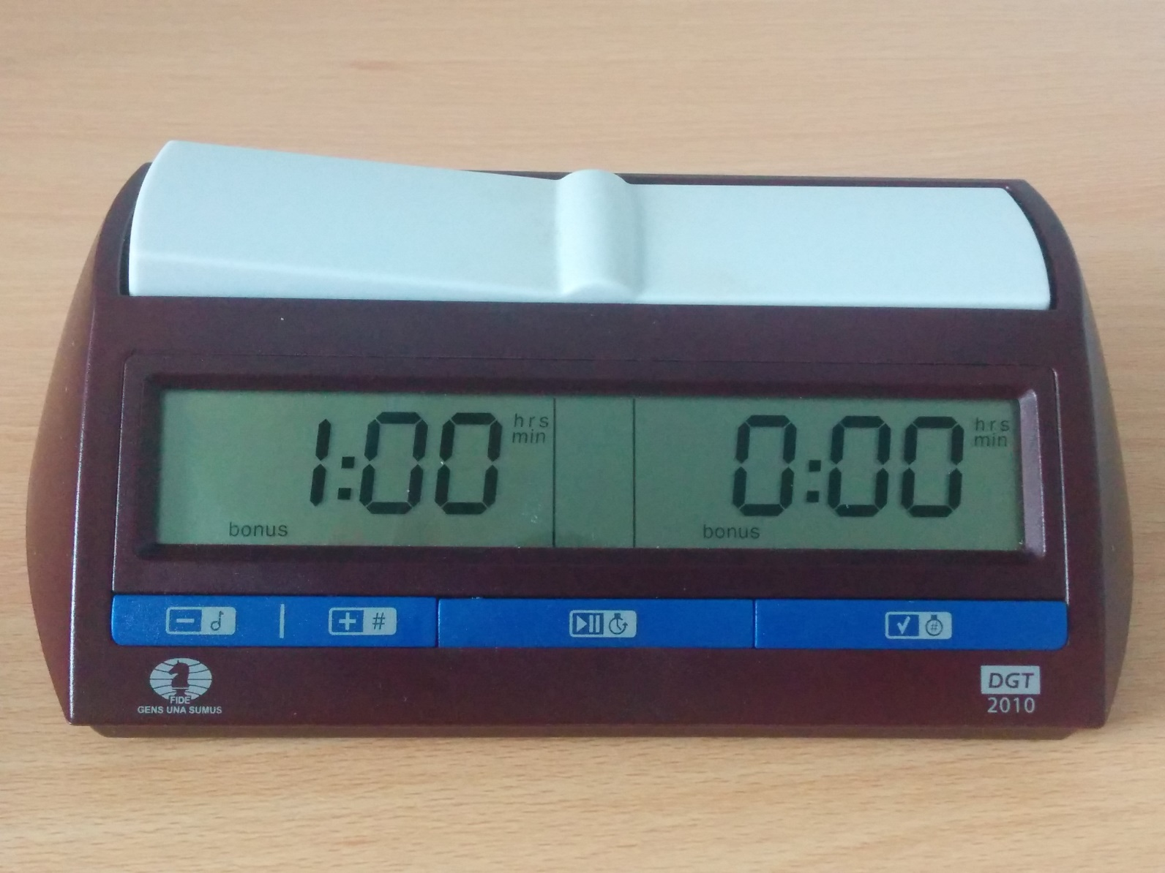

In the same way, the second digit needs to be set to a 1.

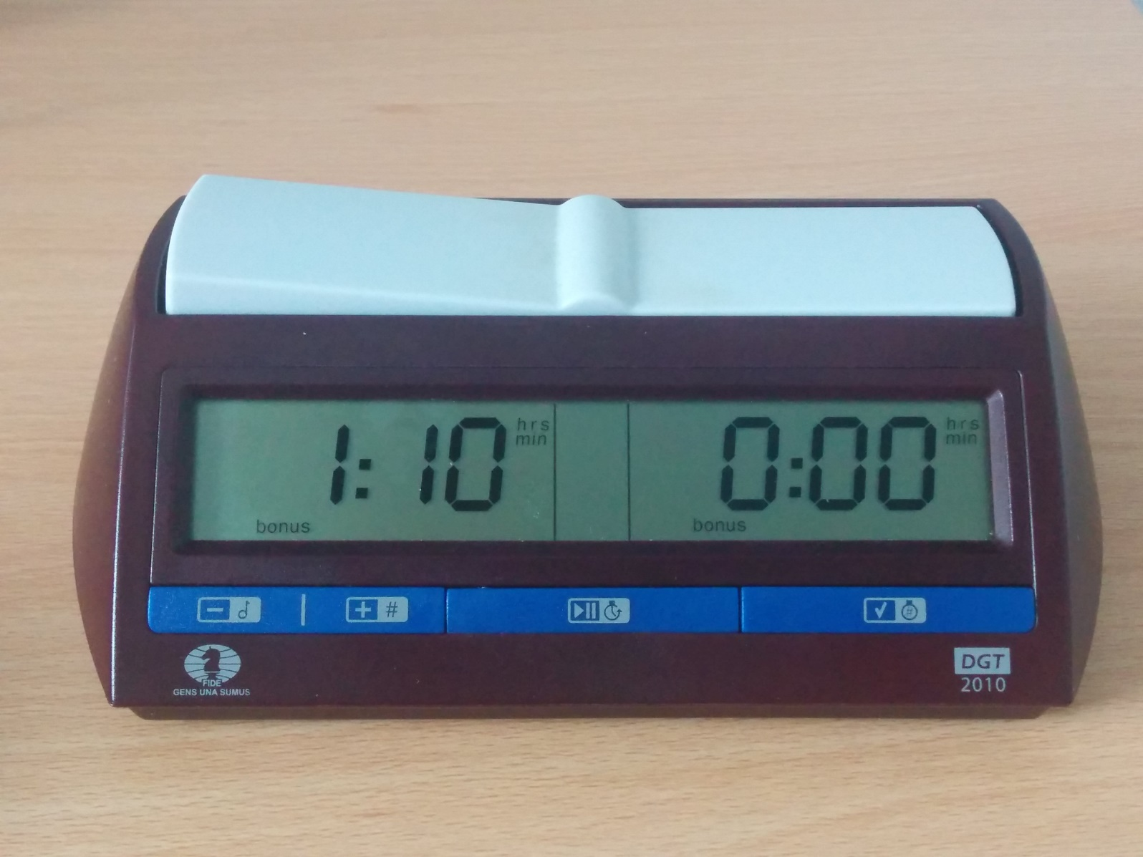

At this point, we have set the left time display correctly, and so we can just press √ to set the third digit to a 0. Once pressed, you will have the opportunity to set the seconds:

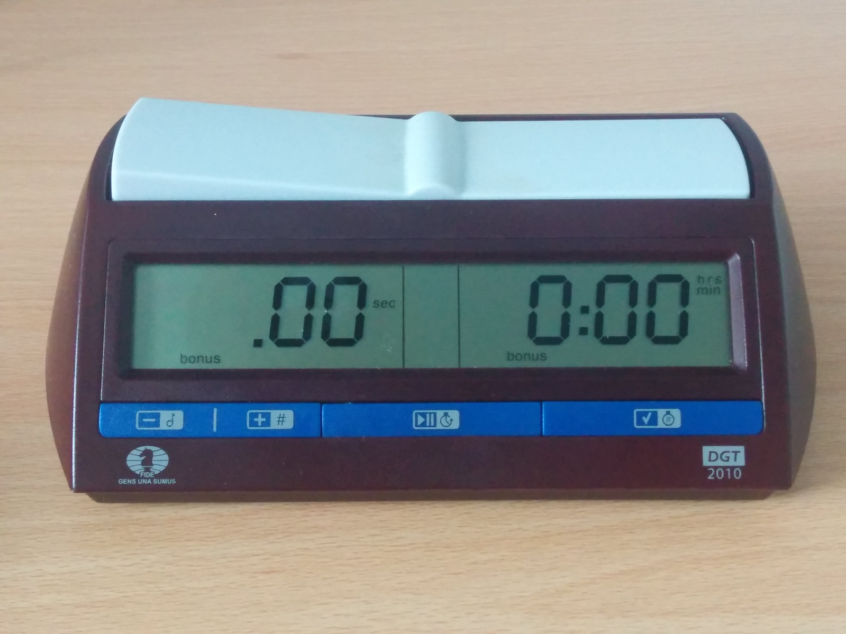

Please note: This is not where the increment is set! The number of seconds should be set to 0. So √ can be pressed twice to move on to the display on the right.

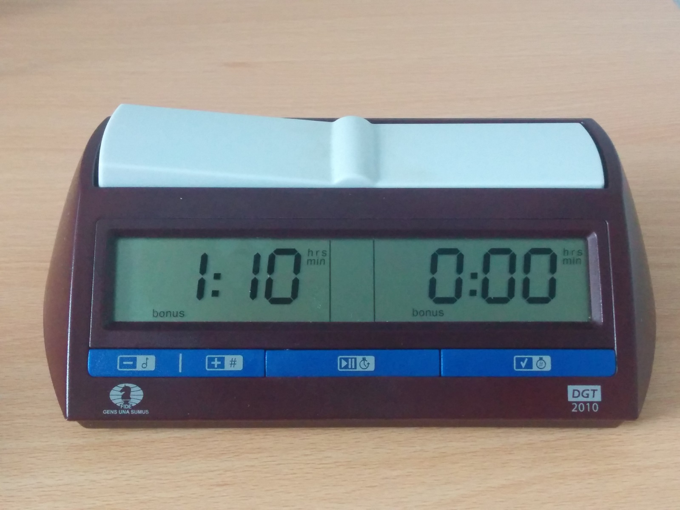

At this point, you set the right-hand display in the same way as the left display.

Setting the Increment

Once you have set both clocks to 1:10 and 0 seconds, you will reach the following.

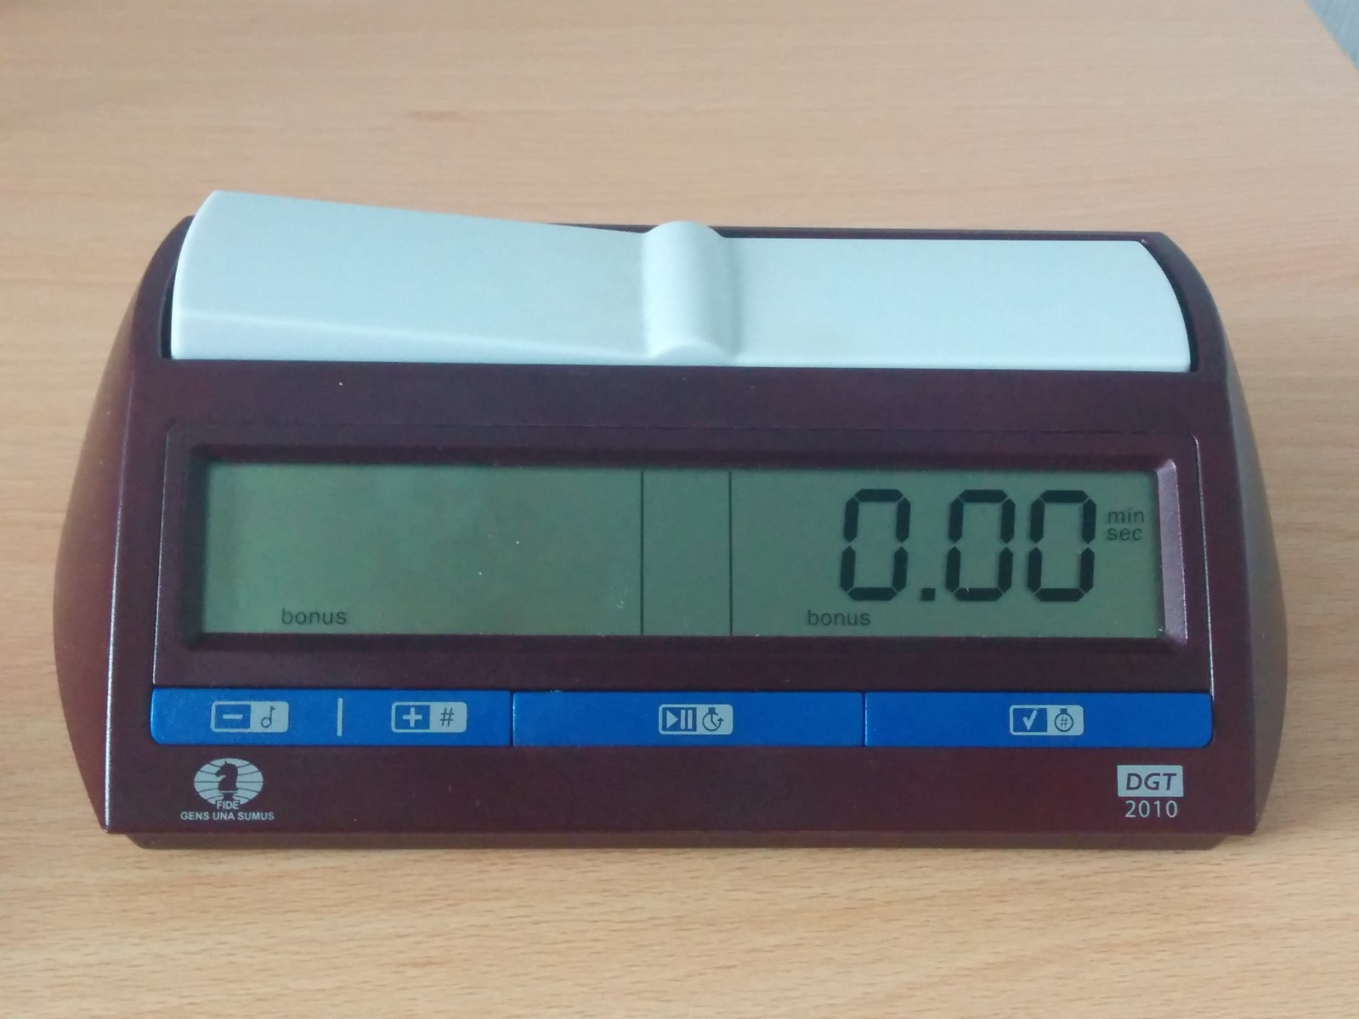

At this point, you need to set the increment to 0.10 – a 10 second increment. This is done using –/+ and √ as you did when setting the time.

Setting the Moves

Having set the increment, you reach this screen.

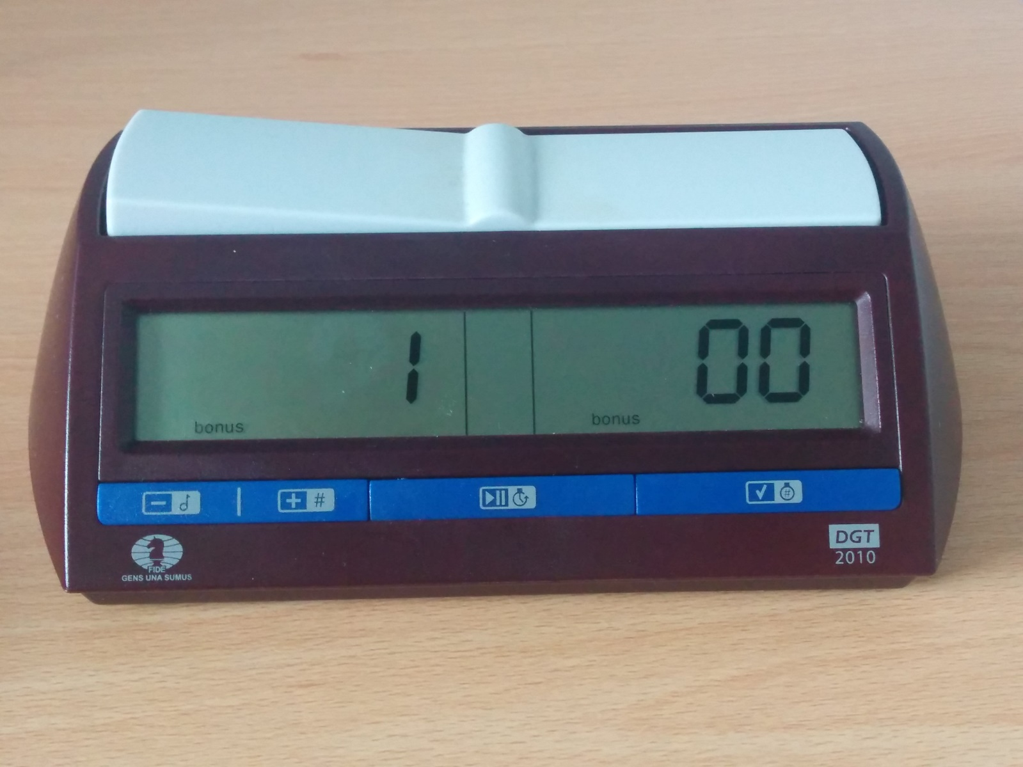

This screen sets the number of moves in the first time period. You may think that you need to set this to 30, because the first time period is 30/70. Please, **DO NOT** do this.

By leaving it at 00, the second time period – the 10 minutes – will be added once one clock reaches 0.00. By setting it to 30, the second time period will be added once a particular clock has pressed 30 times. This has massive potential for disaster – if a clock is pressed spuriously (or not at all!) for some reason, then the clock may add/not add the time as appropriate, and you have a big problem to resolve. Ask me in person if you want to hear the horror story about this! This is why the Laws of Chess are written in the way that the second time period should be added at a flag fall, rather than after a certain number of moves; even with analogue clocks.

Because we’re setting this to 00, we can just press √ to go through the zeros and move on.

Setting the Second Time Period

The last thing of note that we need to do is set the final time period to 10 minutes.

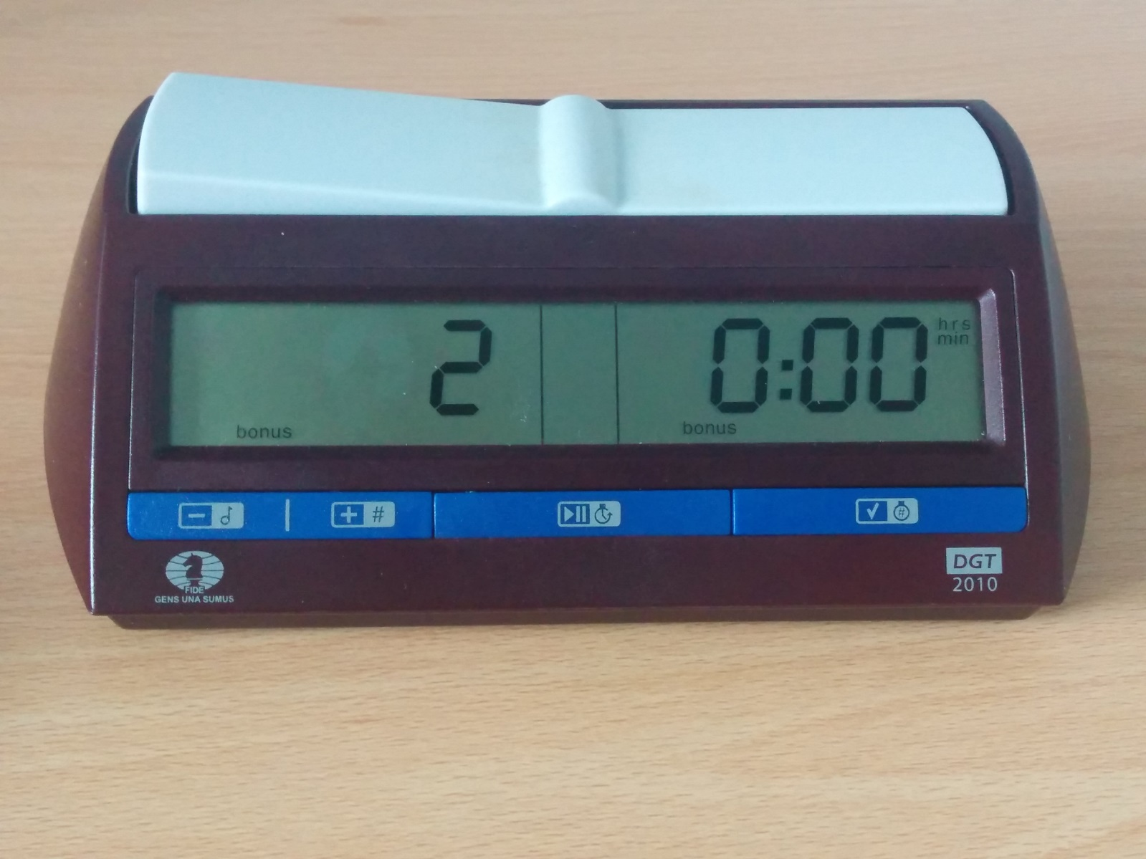

The 2 shows that we are in time period 2, and we need to change 0:00 to 0:10 using –/+ and √ as we have to set everything else.

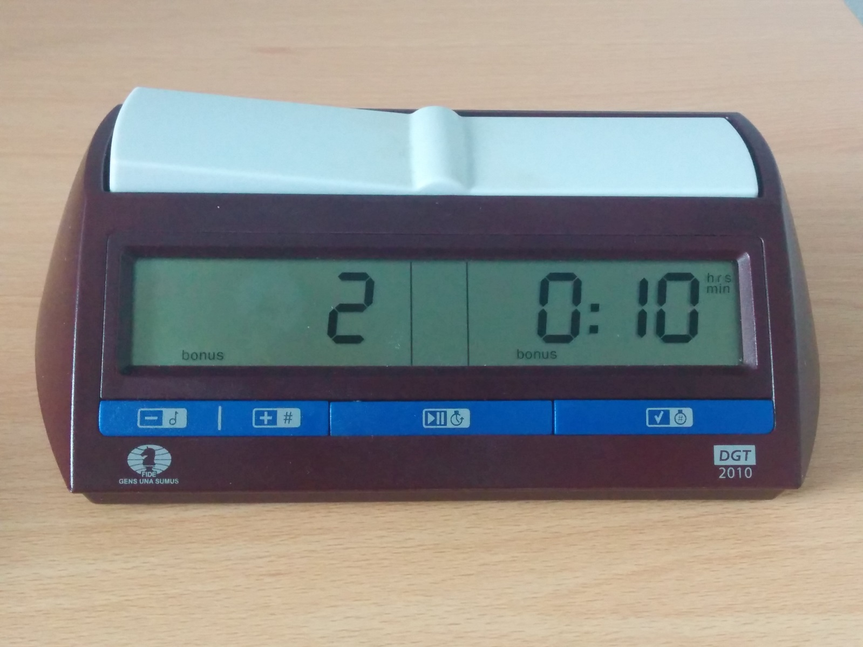

Once that has been set, we must again set the seconds to 0, but we are not invited to re-set the increment – that applies to all periods – and so instead, we move to the moves screen.

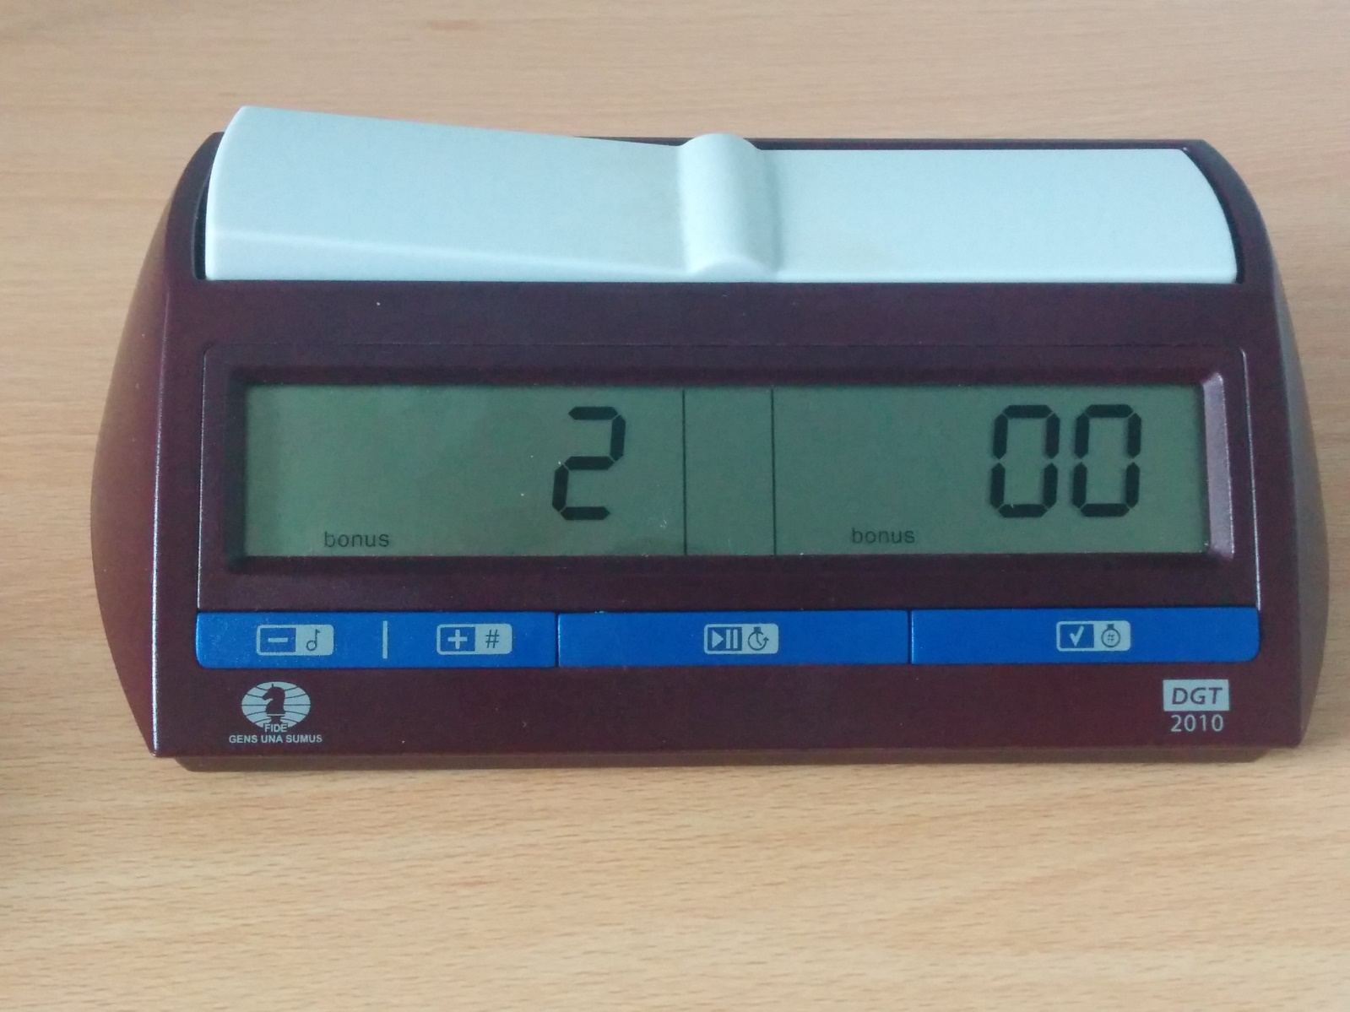

Which again must be set to 00, because it is the final time period.

Cycling Through the Remaining Screens

Because mode 21 is a generic mode designed to set anything, the setting allows for 4 time periods. We only needed 2. Nevertheless, we need to scroll through all of the other 0s in time periods 3 and 4 to set the clock fully.

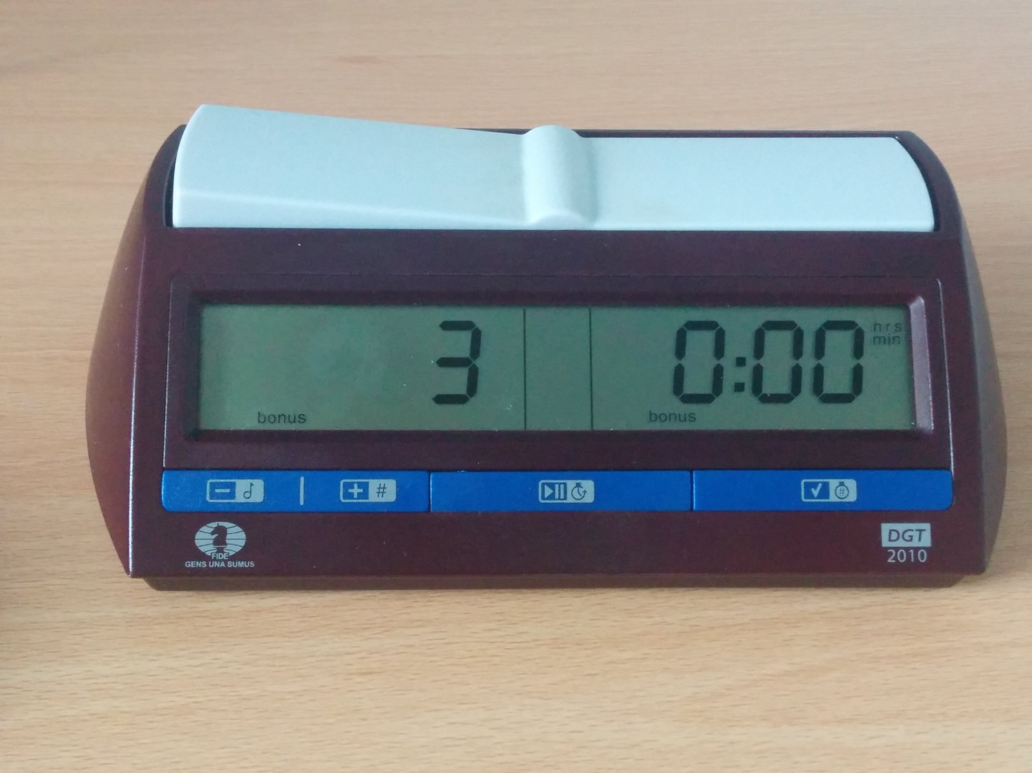

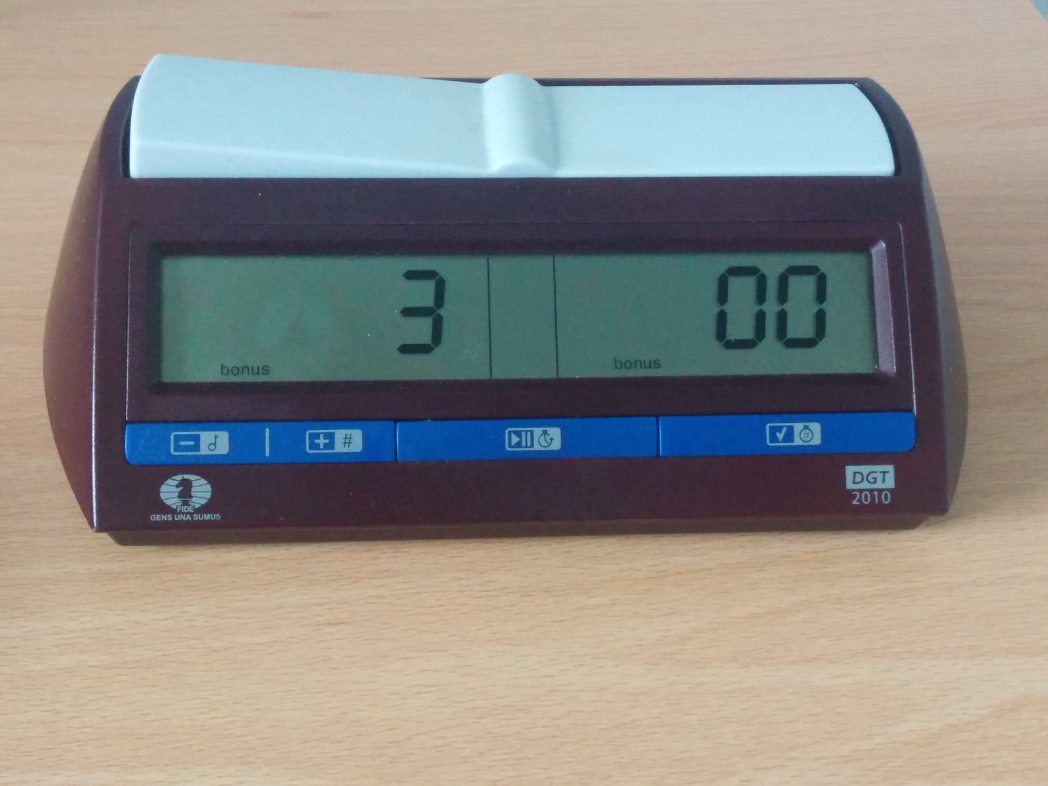

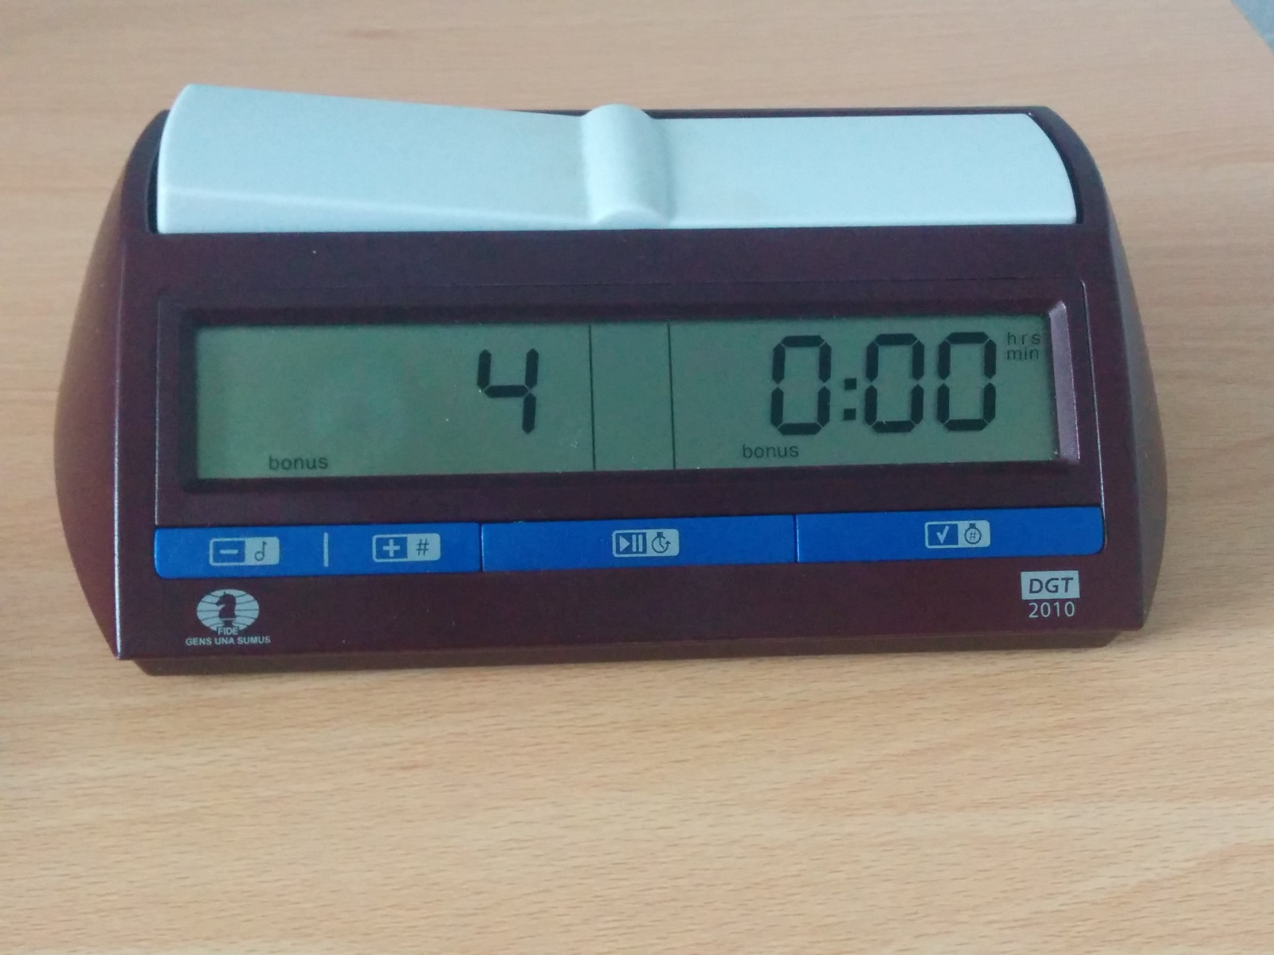

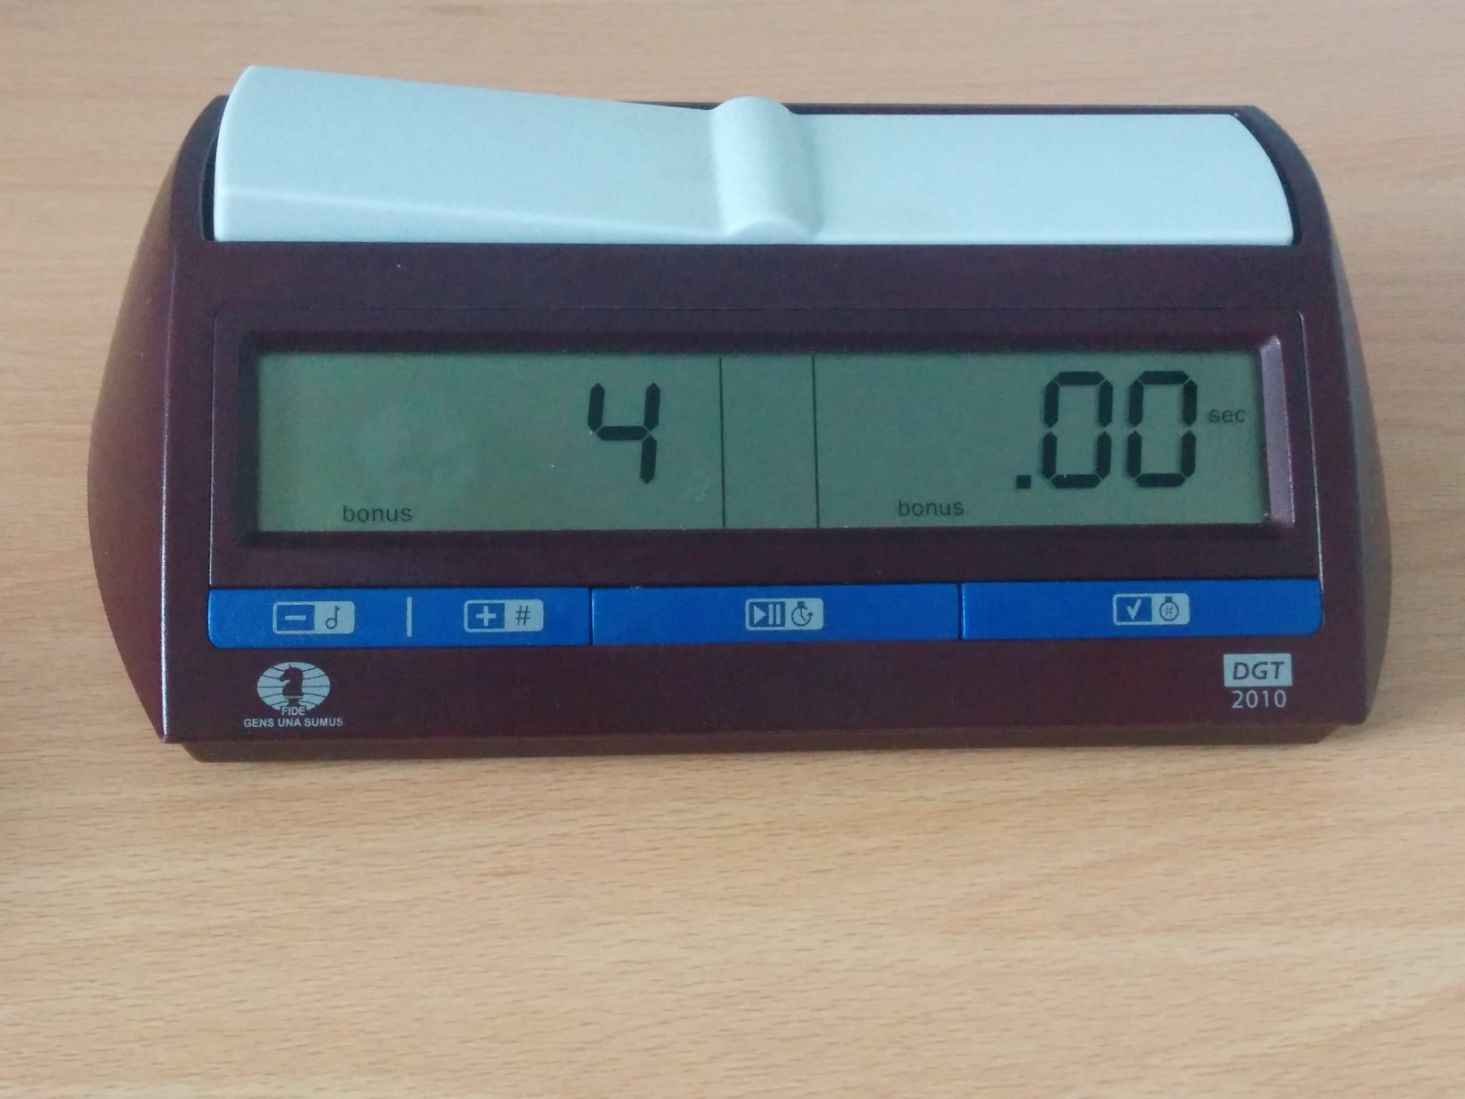

The Finished Setting

Having scrolled through those, we reach this screen.

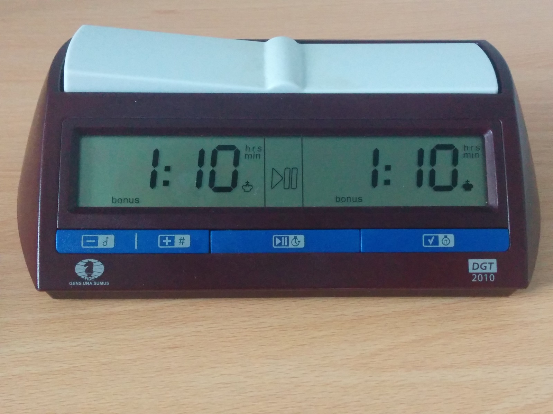

And finally, we are able to play chess with the clock! All we need to do is press the play button in the middle.

Once you’ve done this, you might think the clock isn’t working, because it shows 1:10 for a while before dropping to 1:09. Why is it doing this?

The clock has been set to 30/70 in the first time period, with a 10-second increment per move. So when the clocks are started, for move 1, you therefore actually have 1:10.10 on your clock, and not 1:10.00. As a result, the clock will take 10 seconds to drop below 1:10. I have seen several examples in congresses of players who think their clocks aren’t working for this reason, and remedy this by pressing the levers at the top in the way they might with an analogue clock. Of course, this then makes the problem worse, because they’re increasing their time gaining an increment, and so getting further away from the 1:10, and possibly rise up to 1:11!

The clock will be working if the colon between the hours and minutes on the clock of the player whose turn to move (i.e. their lever is up) is flashing. Please ensure that when you start your games, the lever of the player who has white is “up”, and so when you press play, the white clock starts running down. If the black clock starts running down, then you may have to press the lever so that white’s clock runs down. This is a reasonable enough solution at the start, but is a very good reason for not setting the move counter to 30 earlier on!

Adding Two Minutes/Other Clock Adjustments

There are reasons why two minutes might need to be added to the clock:

1. An illegal move has been completed
2. An incorrect draw claim has been made (e.g. 50 moves, repetition)

These are not unique to incremental time limits, but nevertheless have been included here for the sake of completeness.

To stop the clock press the play button in the middle. Then press it again, this time holding it for up to 3 seconds. The left-most digit on the left-most clock will begin to flash. Using –/+ and √ as appropriate, increase the relevant digits so that the player who should benefit from the time gains two minutes. If the original time was 0:59, then three digits might need to be adjusted! It is worth thinking about what changes to make before you start editing the clock.

With increments, however, it may also be necessary to adjust the clock of the player who makes an illegal move. By Law, he will have gained 10 seconds he never should have had – he only fell victim to the two-minute penalty once he pressed the clock. In addition to adding two minutes to one clock, you will need to take 10 seconds off the other clock. This may be more hassle than it is worth if both players have more than an hour remaining, but if both players are down to a few seconds, this 10 second adjustment is, in my opinion, essential. Between those two extremes there’s a judgement call to be made that I will leave to those effected by this!